**Разработка урока обучению письменной речи**

**с использованием процессуального подхода**

Яковлева Маргарита Анатольевна,

учитель английского языка высшей кв. категории

МОУ Ермаковская СОШ

**Situation: Giving information about Russia.**

**Writing skills:**

1. Paragraphing.

2. Organizing of information in descriptions of a country.

**Language Focus:**

**Grammar:** geographical names, numerals, Present Active \Passive Voice, to be (rich in…) …, to have…, there is\are/

**Topical Vocabulary:**

geographical position, landscapes, population, sights, climate, symbols, nationalities, mineral resources, industries, proper names.

**Function:** giving information

**Level**: intermediate

**Describing a country**

|  |
| --- |
| A young people’s geographical magazine has asked readers to write about their countries. The best description will win a prize. Write a description that you can send to the magazine. |

**Discussion 1. When do you usually describe a country? In a geography or in**

**a literature lesson? What about the English lesson?**

**2. What do you pay attention in each particular case to?**

**3. What do you think about when you describe a country?**

**Writing descriptions Ex. 1 *Learning to write.*** *When you write a description of a*

*country you have to organize the information in a way that*

*makes things clear to the reader. One common pattern is:*

Plan of description

1. Name of the country

2. History

3. Geographical position

4. Landscapes

5. Climate.

6. Industry, agriculture

7. Population

8. Attractions

**In pairs. Read the text and choose the title for each paragraph from the plan above. What point was not mentioned?**

The United Kingdom, often further abbreviated to “UK”, and is the political name of the country which is made of England, Scotland, Wales and Northern Ireland.

Before the United Kingdom was formed it took centuries and a lot of armed struggle was involved. The Celts, Romans, Angles, Saxons, Vikings, Normans invaded Britain in different periods of its history. They mixed with the peoples who were already in Britain Isles and imposed their own way of living, culture and language. Christianity came from Rome in 597.

GB is separated from the Continent by the English Channel. It is one of the world’s smaller countries with an area of some 244,100 square kilometers.

The climate is generally mild and temperate. The landscape is rich and varied. Most of the land is agriculture.

**Discussion Ex. 2 Speaking about a country we can describe many things.**

**What can you add to the list? What could be interesting**

**for your English-speaking friend? Work in pairs.**

**Working with words**  **Ex. 3 Work in groups of four and fill in the chart using the**

**words from the box.**

|  |
| --- |
| Plains, oil, anthem, native language, cathedrals, warm, machinery, hills, forests, coal, flag, official language, museums, mild, plants, rivers, lakes, natural gas, modern and ancient buildings, mountains, valleys, iron, gold, cold, factories, nickel, diamonds, nationalities. |

|  |  |
| --- | --- |
| Geographical position |  |
| Landscapes |  |
| Mineral resources |  |
| Symbols |  |
| Population |  |
| Sights |  |
| Climate |  |
| Industry, agriculture |  |

**Working with sentences Ex. 4 Write a short description of a country filling the gaps**

**with the words given in the box.**

The United States of America occupy a large__________. The USA is situated in the central and southern part of_______________ ______________. It is washed by __________ ___________

in the east and by______________ ____________ in the west. It stretches from ________ in the north to Mexico, the Gulf of Mexico, and the Gulf of California in ________________.

|  |
| --- |
| Territory the Atlantic Ocean Canada  the Pacific Ocean Northern America the south |

**Ex. 5 Imagine you are a group of businessmen and you want**

**to develop your country’s industry. Study the map of**

**mineral resources and write a short report about what**

**your country is rich in.**

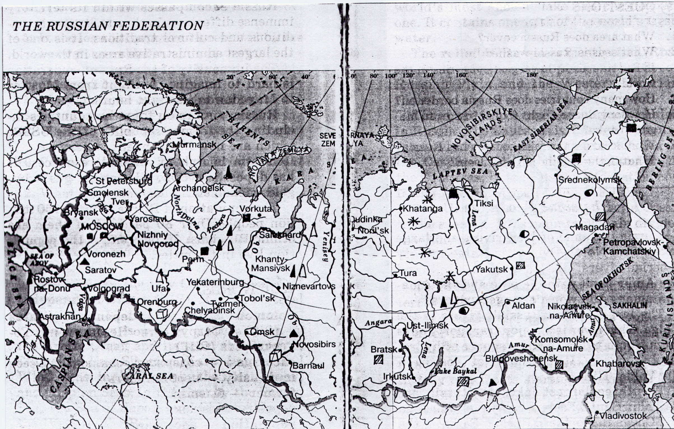

iron diamonds *

black coal gold

brown coal oil

salt natural gas

Russia is an important industrial center. It is the center of… and… industry. There are many…, …and mines in Russia. Russia is rich in…It has deposits of…In the North there are…

In the South… The Central Region is rich in…In the Urals… In the Volga Basin…In the Western and Eastern Siberia…the Far East is rich in…

**Ex. 6 Each country has its symbols. They can be state symbols and popular symbols. National anthem, national flag, national motto, national seal are state symbols. People are proud of them and honor them. There are some other things that symbolize every country. People like to show them to the tourists. Working in groups fill in the chart with the symbols of your country and then write their short description.**

The symbols of my country.

|  |  |
| --- | --- |
| National anthem |  |
| National flag |  |
| National motto |  |
| National seal |  |
| Other national symbols |  |

The seal of_______ is put on all official documents signed by the President. It was introduced in_________ by the Russian tsar Ivan III. The seal shows___________. The national flag of_________ is made up of________,_________ and _________ stripes. The _____ colour symbolizes courage, the________- purity, the __________ colour - firmness and justice. By a special Act of the Gouvernment in____ the song_________ became the National Anthem of_________.

Other R__________symbols are…

**Ex. 7 Every country has its own famous people, traditions, places to visit. The Sunday newspaper *The Observer* offered its own selection of the 99 best items in Great Britain. Among them Madam Tussaud’s Museum, Loch Ness Monster, red telephone boxes, double-deckers, Big Ben, soccer and many others. Work in groups and make up the list of 10 best items of your country. Then change the lists with other groups.**

**Ex. 8 Write a short story about the most attractive things in your country.**

The best items of my country are… Besides… They are… People like… because… I think… is worth seeing (reading, hearing, playing). It is also interesting that…

**Write it yourself Variant 1.**

**Write a description of your country.**

1. In groups of five or six distribute the tasks. Each of you should choose a topic and write a piece of information. As you write keep in mind the information you learnt about this topic in the exercises and in the readings. Do not worry much about spelling, grammar and punctuation. You have 10 minutes.

2. In your group exchange the information and put it into paragraphs.

Then improve your description using ‘Improving your writing’

checklist.

3. Exchange your descriptions with those of others groups. Are there

any improvements you wish to make to your peers writing?

Use the ‘Questionnaire for peers’ evaluation’.

4. Now you have feedback about your descriptions from several

classmates. You can use what you learnt about your writing to

improve your work.

**Variant 2.**

1. **Write a description of your country.**

Use the plan:

1. Location
2. Mineral resources, industry
3. History.
4. Population.
5. Attractions.

6) Symbols

Then improve your letter using ‘Improving your writing’ checklist.

1. Exchange your letters with your classmates. Are there any

improvements you wish to make to your peer s writing? Use the

‘Questionnaire for peers’ evaluation”.

3. Now you have feedback about your letter from several classmates.

You can use what you learnt about your writing to improve your

work

**To the Student**

**To the Student studying in class**

If you are working with this book in a class, follow these general instructions. They will help you improve your writing:

* When you are asked to ‘work in pairs’ or ‘with a partner’ try to follow the instructions carefully. You can often learn more quickly through discussion than by doing exercises silently.

- Do not worry about making mistakes. The most important thing to pay attention to in

your writing is the extent to which it communicates. Spelling, punctuation and matters of

handwriting are important but subordinate to this purpose.

**To the self-study Student**

If you are not in class, follow these general instructions:

-go through the unit carefully, because it is logically structured and is aimed to help you to make a good piece of writing

-when you are doing exercises it is not enough to “fill in” the text. Write the whole text to develop your writing skills.

- as you go though a unit, check your work with the key. The keys are to help you-use them.

-Write the first version and use the **Improving Your Writing** Checklist and **Questionnaire for self-evaluation.** Then improve your writing.

**-**When you think your writing is as good as it can be, give it to someone else to read. Another person can see things that are invisible for you.

**Improving your writing. Using the checklist**

This list of things to check in a first version of a piece of writing is very important. You will be asked to use it in many of the units and it should help you produce clearer, more effective writing.

FIRST CHECK

**Check that your writing makes sense**

• Is it correctly organised on the page?

(Writing models in each unit will help you check this.)

• Is the information presented in a clear, logical order?

• Have you put in all the information your reader needs?

• Have you put in unnecessary information?

SECOND CHECK

**Check that you have used the right words**

• Have you used any words that are too formal or informal?

• Can you replace any of the words in your writing with more precise vocabulary?

**Check spelling and punctuation**

• Have you made any spelling mistakes?

• Have you punctuated your writing correctly?

**Check the grammar**

• Have you made any grammatical mistakes?

**ESPECIALLY**

• Subject/Verb agreement

• Correct article

• Word order

**Questionnaire for self-evaluation**

1. Am I sharing my impressions clearly enough with my reader?
2. Have I missed out any important points of information?
3. Are there any points in the writing where my reader has to make a “jump” because I’ve omitted a line of argument or I’ve forgotten to explain something?
4. Does the vocabulary need to be made stronger at any point?
5. Are there some sentences which don’t say much or which are too repetitive and can be missed out?
6. Can I rearrange any sets of sentences to make the writing clearer or more interesting?
7. Do I need to rearrange any paragraphs?
8. Are the links between sections clear? Do they guide my reader through the writing?

(After Hedge, Tricia (1988) Writing OUP.)

**Questions for peers’ evaluation (after the 1st draft)**

1. What do you like most about the writing?
2. What is the main idea?
3. Who is the audience, and what is the purpose?
4. What convincing details does the writer use?
5. Where could the writer add details to make the piece more convincing?
6. What areas in the writing seem unclear?
7. How could the writer make the piece clearer?

**Writing profile. Evaluation tools**

Your second draft will be evaluated after these criteria.

**Communicative quality** 5. Communicates what is intended clearly and effectively.

4. Communicates intentions quite well.

3. Communicates intentions adequately.

2. Does not communicate intentions adequately.

1. Fails completely to communicate intentions.

**Logical organization** 5. Information and ideas extremely well-organised.

4. Good organisational structure.

3. Organisational structure evident with some breakdowns.

2. Difficult to identify logical structure.

1. No logical structure evident.

**Layout and presentation** 5. Extremely well-presented. Shows complete familiarity

with conventions.

4. Reasonably well-presented; a few minor problems with

conventions.

3. Acceptably presented but needs more familiarisation with

conventions.

2. Some serious gaps in familiarity with conventions.

1. Fundamental lack of familiarity with conventions.

**Grammar** 5. Wide range and excellent control of appropriate

grammatical structures.

4. Effective use of a good range of grammatical structures.

3. Adequate range and control of grammatical structures.

2. Limited range and poor control of grammatical structures.

1. Extremely limited range and control of grammatical

structures.

**Vocabulary** 5. Wide range and excellent control of appropriate

vocabulary.

4. Effective use of a good range of vocabulary.

3. Adequate range of fairly appropriate vocabulary.

2. Limited range of vocabulary.

1. Extremely limited range of vocabulary.

**Handwriting, punctuation,**

**spelling** 5. No faults.

4. Occasional faults.

3. Adequate but needs improvement.

2. Significant weaknesses.

1. Little knowledge of or ability to handle the basic

conventions.

(Adopted from Hopkins, Andy (1995). *“Perspectives*”, p. 9.- Longman)

**Scoring**

31-35 points –“5”

26-30 points -“4”

21-25 points -“3”

**Marking Code**

You should know the marking code to improve your work.

|  |
| --- |
| **Symbol Error Example**  **WF** wrong form the best will be its achievements  **WW** wrong word patient, funny and kindly  **T**  wrong tense In the last two weeks you didn’t have much fun.  **Om**\^ something is missing You arrived in London ^ the 1st  **Sp.** wrong spelling confortable  **WO** wrong word order You havn’t seen yet London.  **P**  wrong punctuation Sincerely yours Kate.  **V**  wrong verb form The Titanic sunk very quickly.  **//**  new paragraph needed  **O**  not necessary John came in and he sat down.  **?** I don’t understand what you are trying to say.  **Sence**  This isn’t quite right: it needs clearer expression  **!!** You really should know what’s wrong here because  -we’ve just done it in class  **Agr.** agreement(subject-verb, adj.-noun) In Moscow there is many  museums.  **Art**. wrong or omitted article a climate  **F** untruth  **Log**. illogical  **Rep**. repetition I took part in the singing  competition. I won this competition.  **Prep.** preposition I’m interested for music.  **Style**  the task is not compiled |

**Keys**

**Describing a Country**

Ex. 1 The plan of the text

2. Name of the country.

3. History.

4. Attractions.

5.Climate, landscapes, agriculture.

Geographical position, industry and population were not mentioned.

Ex.3

|  |  |
| --- | --- |
| Geographical position |  |
| Landscapes | Plains hills, forests rivers, lakes, mountains, valleys |
| Mineral resources | oil, coal, natural gas, iron, gold, nickel, diamonds |
| Symbols | anthem, flag |
| Population | native language, official language, nationalities |
| Sights | cathedrals, museums, modern and ancient buildings |
| Climate | warm, mild, cold |
| Industry, agriculture | machinery, plants, factories |

Ex. 4

The United States of America occupy a large territory. The USA is situated in the central and southern part of Northern America. It is washed by the Atlantic Ocean in the east and by the Pacific Ocean in the west. It stretches from Canada in the north to Mexico, the Gulf of Mexico, and the Gulf of California in the south.

Ex. 5

Russia is an important industrial center. It is the center of agriculture and big industry. There are many plants, factories and mines in Russia. Russia is rich in mineral resources. It has deposits of oil, natural gas, iron, black and brown coal, salt, gold, diamonds…In the North there are deposits of natural gas, coal and oil. In the South –those of salt, black coal, iron. The Central Region is rich in iron and black coal. In the Urals there are deposits of gas, oil, brown coal. In the Volga Basin Russia is rich in iron. In the Western and Eastern Siberia there are deposits of gold, diamonds, coal and gas. The Far East is rich in gold and brown coal.

Ex. 6

The seal of Russia is put on all official documents signed by the President. It was introduced in the 16th century by the Russian tsar Ivan III. The seal shows an eagle with two heads. The national flag of Russia is made up of white, blue and red stripes. The red colour symbolizes courage, the white - purity, the blue colour- firmness and justice. By a special Act of the Gouvernment in the song by Alexandrov became the National Anthem of the Russian Federation.

Other Russian symbols are matrioshkas, Russian chastushkas, bread and salt as the symbol of lifegiving food, three horses, gilded domes of churches and cathedrals and many others.